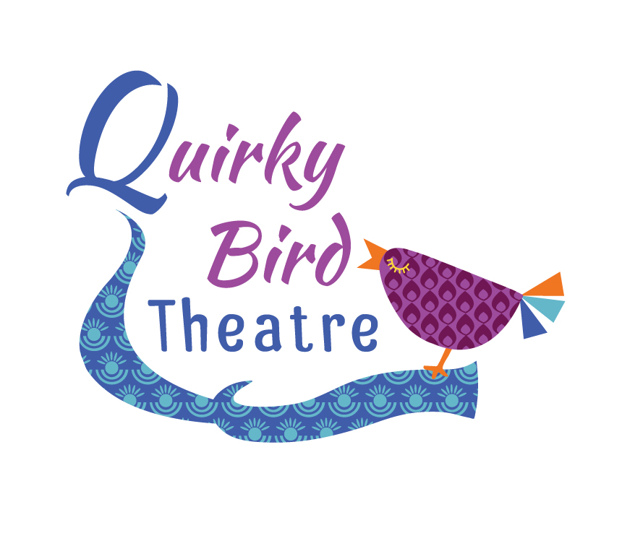
Quirky Bird Theatre
Cancellation Policies
Updated May 2019

For Quirky Bird Juniors Drama Classes;

- We require four weeks notice. Refunds are sessions unattended are not available.

For Speech and Drama private tuition

- We require four weeks notice. Refunds for sessions unattended are not available.

For All School tour

- All tickets are non-refundable
- If 45 days is provided, we will endeavor to re-sell your tickets. If this is successful you will receive 80% of the original ticket price.
- If the performance is unable to happen due to forces outside of our control, all efforts will be made to reschedule this performance. In the instance that is not possible you will receive a full refund minus all expenses incurred by the company in relation to this individual performance.

