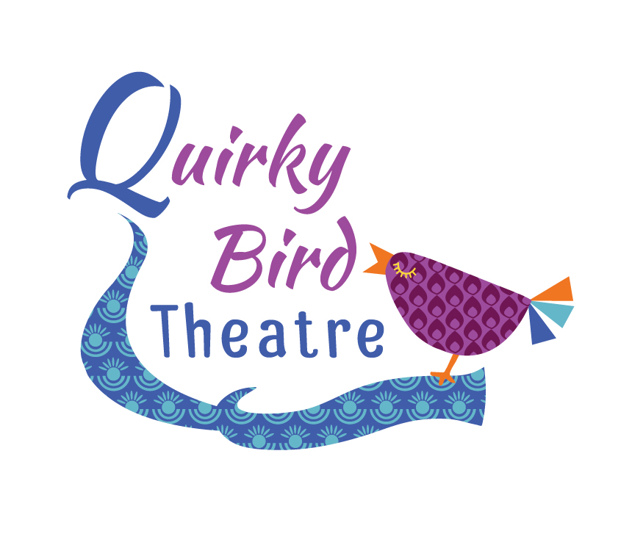 Quirky Bird Juniors
Term Dates and Information

Welcome to Quirky Bird Juniors – thank you for enrolling!

Term Dates and Performances
Each academic year there will be six terms. Parents are invited to join us for the final session each term to see what we have been up to! Times are as followed;

Minis 3.30 – 4.05 Intermediates 4.10 – 5pm Seniors 5pm – 6pm

Session Content
All of our sessions are structured to make students feel confident to respond, therefore particularly in the younger groups we do familiar games and exercises combined with new activities to promote creativity and social interaction.
Previous themes for each terms have been: Toys Alive! Charlie and the Chocolate Factory, Back to School, Stick Man and Let’s Make It!
Our focus is very much process rather than performance so that all children have the opportunity to thrive without fear of embarrassment however we will always encourage all students to take part in the end of term sharing.

Session Information and Uniform
Each session will be held in the upstairs room at The Methodist Church on the High Street (next to Charrins). Please be there ready for a prompt start for each session. The toilet is situated right next to the room where the sessions take place and I would encourage the youngest children to use the toilet before the session begins. Please make sure your child has a drink to bring in with them as we’ll be using lots of energy in each session! Also, where possible please make sure they are wearing comfortable clothing that they can fully move in. I would encourage everyone to wear leggings or tracksuit bottoms. Every student will be given a Quirky Birds T-shirt to wear to each session. This comes as part of your enrolment fee of £15. Any additional T-Shirts needed will be charged at £9.50.

Any questions at all, don’t hesitate to contact me at quirkybirdtheatre@gmail.com or on 07816823555
Anna Friend
Artistic Director
Quirky Bird Theatre
www.quirkybirdtheatre.com

