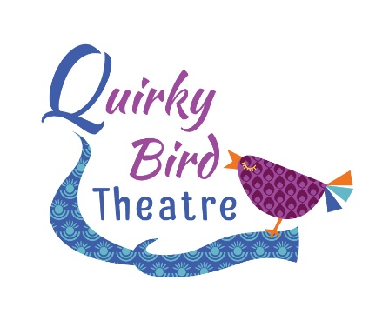
QUIRKY BIRD JUNIORS
WROUGHTON
Term Dates 2018 - 2019
AUTUMN 1 Monday 3rd September – Monday 22nd October (8 Weeks)
AUTUMN 2 Monday 5th November – Monday 17th December (7 Weeks)
SPRING 1 Monday 7th January – Monday 11th February (6 Weeks)
SPRING 2 Monday 25th February – Monday 1st April (6 Weeks)
SUMMER 1 Monday 29th April – Monday 20th May (4 Weeks) No session Easter Mon.
SUMMER 2 Monday 3rd June – Monday 22nd July (8 Weeks)
Table of Fees
Term | Mini Fee £4.50 p/w | Intermediate Fee £5 p/w | Senior Fee £6.50 p/w
Autumn 1 | 36.00 | 40.00 | 52.00
Autumn 2 | 31.50 | 35.00 | 45.50
Spring 1 | 27.00 | 30.00 | 39.00
Spring 2 | 27.00 | 30.00 | 39.00
Summer 1 | 18.00 | 20.00 | 26.00
Summer2 | 36.00 | 40.00 | 52.00
Monthly Payment Plan | 15.00 each month | 16.50 each month | 21.50 each month

Fees payable termly in CASH, CHEQUE OR BACS PAYMENT ONLY. For BACS Payment please use the following details;
Quirky Bird Theatre Sort Code: 404341 Acc No: 82260433
If you would prefer to set up a standing order to spread your payments over 12 months then please contact me. Payment due on the 1st of each month.
Fees are due 7 days in advance of the start of term. We always appreciate prompt payment!
Many Thanks!

