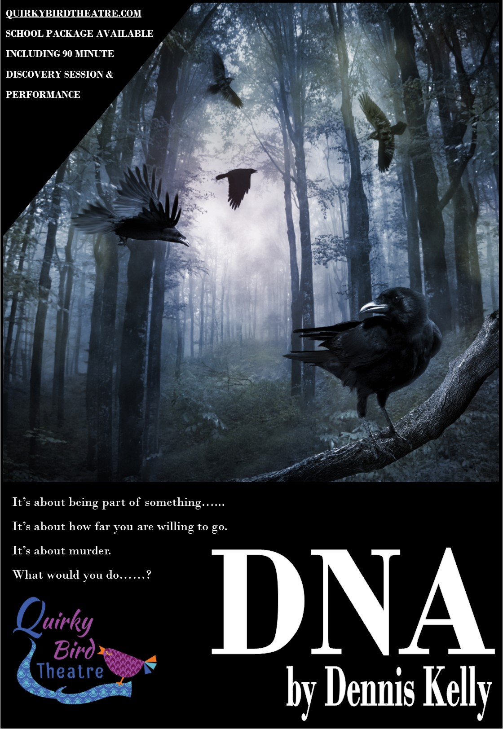

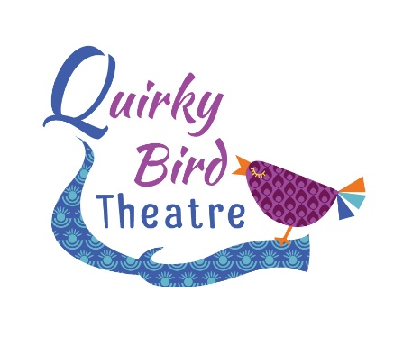

QUIRKY BIRD THEATRE
DNA 2020
SCHOOLS TOUR
INFORMATION & PRICES – SINGLE SCHOOL VISIT

Thank you for interest in our schools tour of DNA by Dennis Kelly. This production has been touring schools since September 2017 and received fantastic student response and feedback.
From the teachers:
I'd like to say a huge thank you to the Director and Cast members at Quirky Bird Theatre. We hired them in to perform DNA and paid for the extra workshop afterwards and the excitement from my students about the play and the characters is still there days later! The cast members were so open and friendly with my students and put them at ease straight away to the point where students who are usually too nervous to perform went on stage and performed in front of the whole hall with confidence and conviction I had never seen before.

Thank you for helping my students understand the text and bring it to life! I will be asking for them to come back again next year.

From the students:
“Amazing acting, created by some talented teenagers.”

“I found it very thought-provoking. The physical theatre aspects were effective and made the monologues interesting and easy to watch”

“The staging was wonderful, it gave such a sense of the location but allowed the actors to full demonstrate their characters desolation”

“Oh wow. Leah. She was incredible. Magnetic in her portrayal.”

“Loved the focus on how silence tells a story, the way the relationships and the subtext was told through silences was exciting”

DATES FOR 2020 ARE;
JAN
Jan 20th The Alma Tavern Theatre, Bristol
2pm & 7pm Tickets £13 (£1 theatre admin fee)
TWO FREE TEACHER TICKETS AVAILABLE
48 seats available. Performance + Q&A Only
Jan 21st The Alma Tavern Theatre, Bristol
2pm & 7pm Tickets £13 (£1 theatre admin fee)
TWO FREE TEACHER TICKETS AVAILABLE
48 seats available. Performance + Q&A Only
Wed Jan 22nd
Thurs Jan 23rd
Fri Jan 24th
MARCH
Mon 16th
Tues 17th
Wed 18th
Thurs 19th
Fri 20th

The schools package now offers the performance followed by 90 minute discussion & ‘Discovery’ exploring the characters, themes and creative process.

All cast members will be involved with the post-performance session where the students have the opportunity to interact with the Director and company about decisions that were made during the rehearsal process and discuss and develop their own stage interpretation. This is led by Anna Friend, Artistic Director of Quirky Bird Theatre. Teaching staff are required to be present throughout the session.
Discovery Session: 90 minutes of discussion and practical exploration of the text. Students take part in a masterclass of the ‘John Tate’ scene unpicking character interactions, line interpretation and individual character choices.

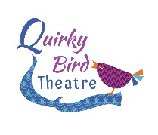

Fees for the package are as followed; (*long distance fees in brackets)
Performance and 90 post show session (max 40 students) £750 (£900)
* long distance rates apply to all venues over 90 miles from our Swindon base.
Cancellation Policy
In the instance that the venue cancels the following will apply;
28 days prior to the performance Full refund
14 days prior to the performance 50% refund
7 days prior to the performance No refund
In the instance that the company cancels a full refund will be issued.
Technical Requirements
Lighting
We require that the following be pre-rigged in anticipation of our get-in;
General Warm Wash
General Cool Wash
Left side isolation
Right Side isolation
Transitional Coloured State A (warm tones)
Transitional Coloured State B (cool tones)
Front Centre Spot
We use a strobe in the first 3 minutes of the show, please advise your students and alert us if this cannot be used prior to our arrival.
Sound Requirements:
Our sound runs from a tablet and needs to be plugged into your sound desk.
If you have any questions please contact us at quirkybirdtheatre@gmail.com
Other
Get in: 1hr mins
Get Out: 30 mins
Minimum performance space: 6m x 6m
Parking for three vehicles to be provided as close as possible to the loading area for our performance space. Where there is no lift and multiple stairs, please provide assistance from your site team.
Tea, Coffee and Water to be provided on arrival.
Anna Friend is DBS checked. Certificate available upon request. Anna Friend is the licenced chaperone for all actors under 16 years of age
If you need any more information regarding this project, please contact Anna Friend at quirkybirdtheatre@gmail.com or call on 07816 823555. For more information about Quirky Bird Theatre please visit our website www.quirkybirdtheatre.com.
In the meantime, if you’d like to book please email us with the dates available marked in order of preference. Please include the contact name, school name and full address with postcode at the time of enquiry.
Anna Friend
Artistic Director, Quirky Bird Theatre
www.facebook.com/quirkybirdtheatre
@quirkybirdrocks

