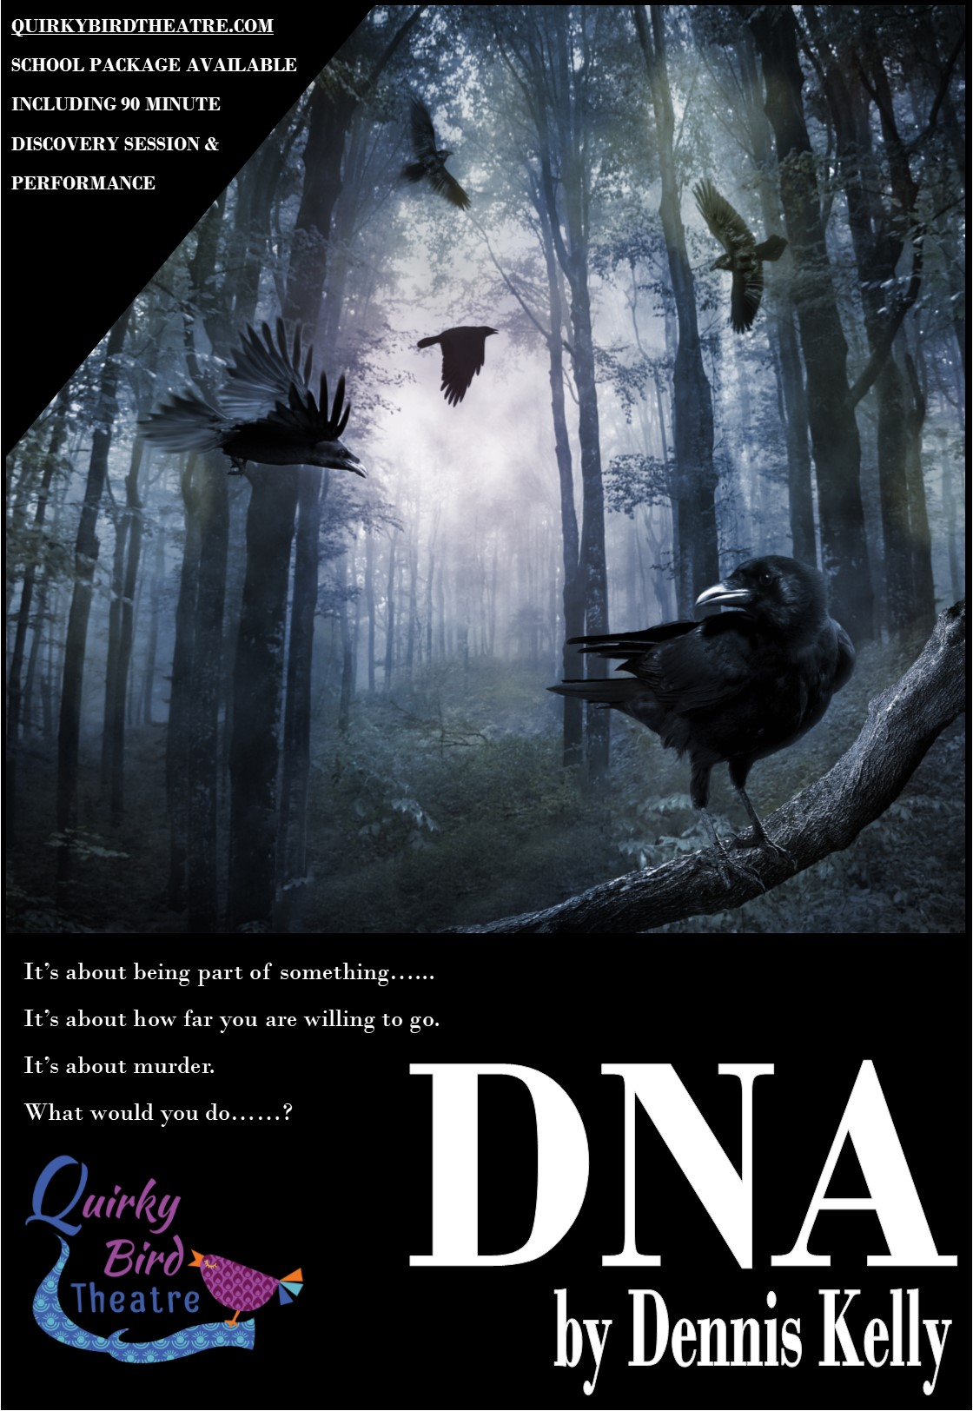

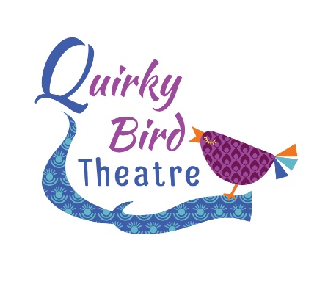

QUIRKY BIRD THEATRE
SCHOOLS TOUR DNA BY DENNIS KELLY 2018
INFORMATION & PRICES

Thank you for interest in our schools tour of DNA by Dennis Kelly. This production has been touring schools since September 2017 and received fantastic student response and feedback.
From the teachers:
I'd like to say a huge thank you to the Director and Cast members at Quirky Bird Theatre. We hired them in to perform DNA and paid for the extra workshop afterwards and the excitement from my students about the play and the characters is still there days later! The cast members were so open and friendly with my students and put them at ease straight away to the point where students who are usually too nervous to perform went on stage and performed in front of the whole hall with confidence and conviction I had never seen before.

Thank you for helping my students understand the text and bring it to life! I will be asking for them to come back again next year.

From the students:
“Amazing acting, created by some talented teenagers.”

“I found it very thought-provoking. The physical theatre aspects were effective and made the monologues interesting and easy to watch”

“The staging was wonderful, it gave such a sense of the location but allowed the actors to full demonstrate their characters desolation”

“Oh wow. Leah. She was incredible. Magnetic in her portrayal.”

“Loved the focus on how silence tells a story, the way the relationships and the subtext was told through silences was exciting”

The schools package now offers the performance followed by 90 minute discussion & masterclass exploring the characters, themes and creative process.
All cast members will be involved with the post-performance session where the students have the opportunity to interact with the Director and company about decisions that were made during the rehearsal process and discuss and develop their own stage interpretation. This is led by Anna Friend, Artistic Director of Quirky Bird Theatre. Teaching staff are required to be present throughout the session.
Discovery Session: 90 minutes of discussion and practical exploration of the text. Students take part in a masterclass of the ‘Hello Adam’ scene unpicking character interactions, line interpretation and individual character choices.
We can be flexible on this schedule to a certain degree but the main things we must consider is the return to home time for our young performers and so travel time is a factor. On some occasions we would look for an earlier start time to accommodate this. Centres over 90 miles away will be asked to accommodate an earlier start time and fall under our long distance pricing.
All bookings are subject to a £100 confirmation fee which allows us to secure the performance rights from Casarotto acting for Dennis Kelly. This must be sent by post in order for us to confirm the booking.
Fees for the package are as followed; (long distance fees in brackets)
Performance and 90 post show session (max 40 students) £750 (£900)
* All bookings are subject to our cancellation policy.
If you need any more information regarding this project, please contact Anna Friend at quirkybirdtheatre@gmail.com or call on 07816 823555. For more information about Quirky Bird Theatre please visit our website www.quirkybirdtheatre.com.
In the meantime, if you’d like to book please complete the form below with a range of dates and we will get this confirmed for you. If you contact us by email please include the contact name, school name and full address with postcode at the time of enquiry.
Anna Friend
Artistic Director, Quirky Bird Theatre
www.facebook.com/quirkybirdtheatre
@quirkybirdrocks

Booking form

School Name:
School Address:

School Contact Number:
Contact Name:
Contact direct email:
Contact direct number:
Number of students for Q&A/Workshop
Preferred Date 1
Preferred Date 2
Preferred Date 3
Ideal Start Time:

Cancellation Policy
In the instance that the venue cancels the following will apply;
28 days prior to the performance Full refund
14 days prior to the performance 50% refund
7 days prior to the performance No refund
In the instance that the company cancels a full refund will be issued.

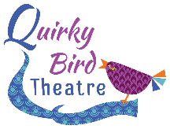

Technical Rider
Lighting
We require that the following be pre-rigged in anticipation of our get-in;
General Warm Wash
General Cool Wash
Left side isolation
Right Side isolation
Transitional Coloured State
Front Centre Spot
We use a strobe in the first 3 minutes of the show, please advise your students and alert us if this cannot be used prior to our arrival.
Sound Requirements:
Our sound runs from a tablet and needs to be plugged into your sound desk. Please inform us asap if you do not have a sound desk as we can provide our own.
If you have any questions please contact our Technical Manager David Jell at davidjell78@gmail.com
Other
Get in: 1hr mins
Get Out: 30 mins
Minimum performance space: 6m x 6m
Parking for three vehicles to be provided as close as possible to the loading area for our performance space. Where there is no lift and multiple stairs, please provide assistance from your site team.
Tea, Coffee and Water to be provided on arrival.
Anna Friend, David Jell, are both DBS checked. Certificates available upon request. Anna Friend is the licenced chaperone for all actors under 16 years of age

