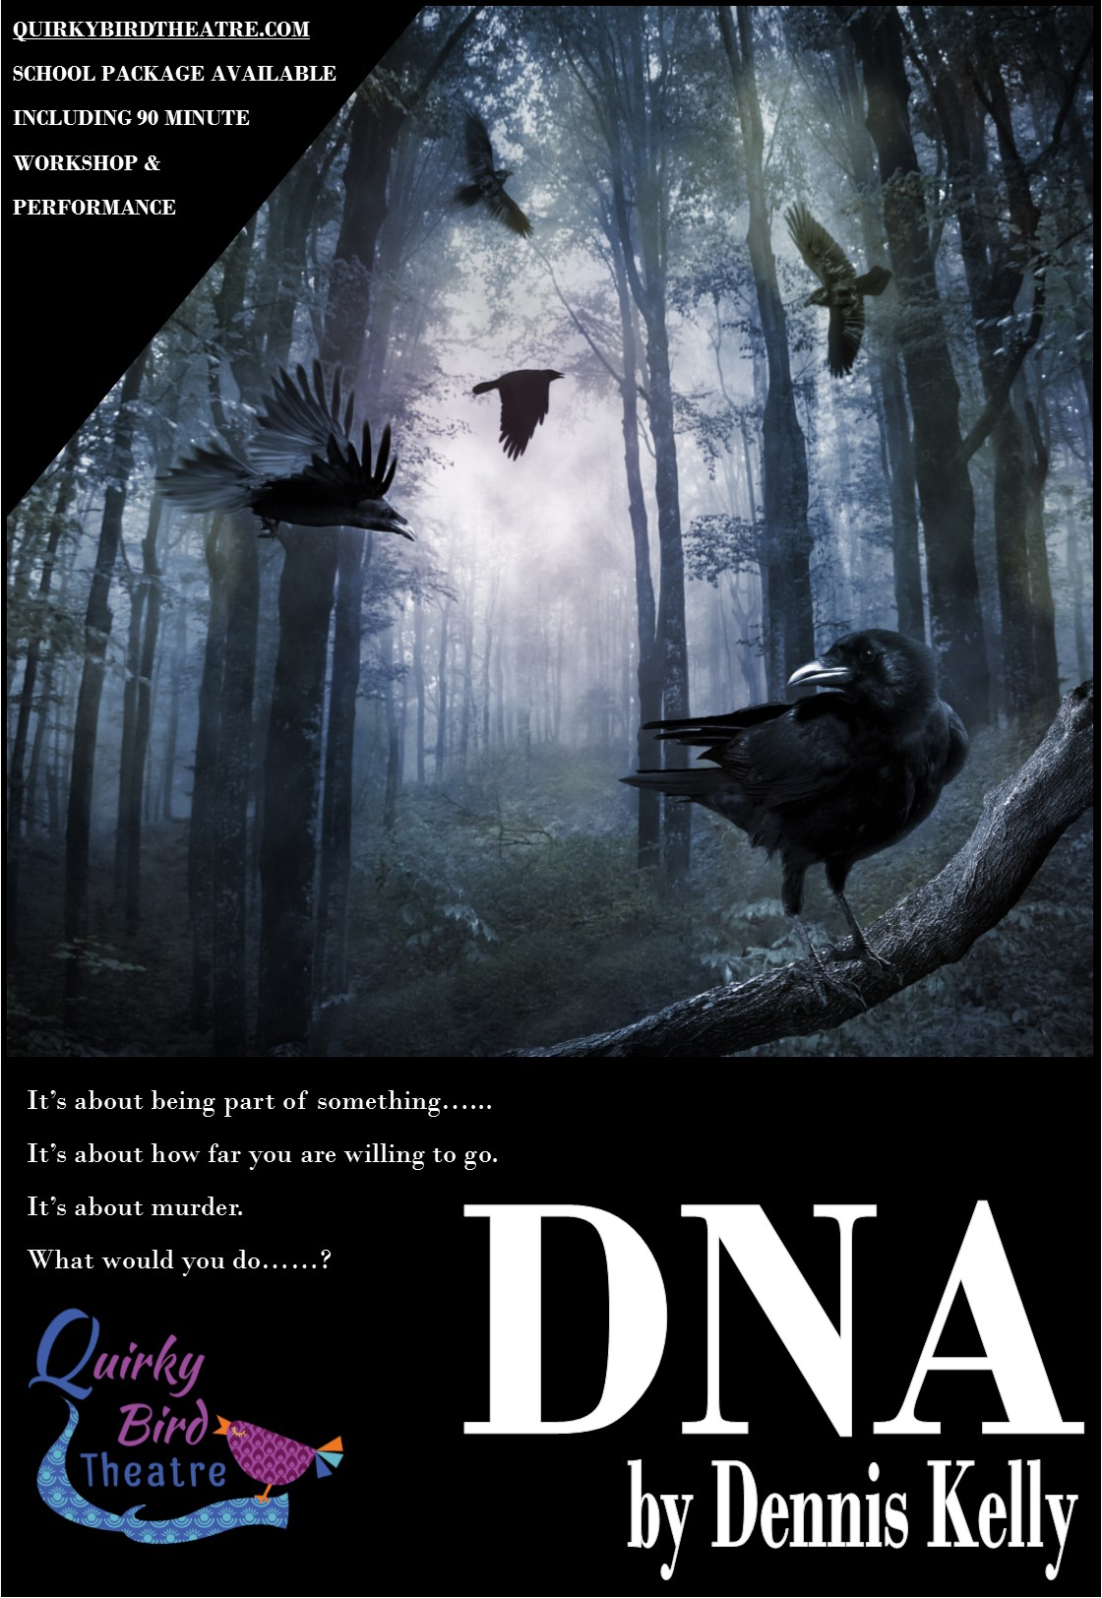

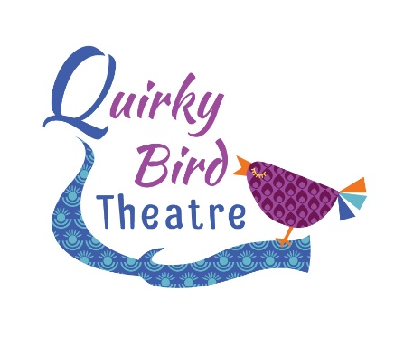

QUIRKY BIRD THEATRE
SCHOOLS TOUR DNA BY DENNIS KELLY 2018
HOST SCHOOL
INFORMATION & PRICES
Thank you for interest in our schools tour of DNA by Dennis Kelly. This production has been touring schools since September 2017 and received fantastic student response and feedback.
From the teachers:
I'd like to say a huge thank you to the Director and Cast members at Quirky Bird Theatre. We hired them in to perform DNA and paid for the extra workshop afterwards and the excitement from my students about the play and the characters is still there days later! The cast members were so open and friendly with my students and put them at ease straight away to the point where students who are usually too nervous to perform went on stage and performed in front of the whole hall with confidence and conviction I had never seen before.

Thank you for helping my students understand the text and bring it to life! I will be asking for them to come back again next year.

From the students:
“Amazing acting, created by some talented teenagers.”

“I found it very thought-provoking. The physical theatre aspects were effective and made the monologues interesting and easy to watch”

“The staging was wonderful, it gave such a sense of the location but allowed the actors to full demonstrate their characters desolation”

“Oh wow. Leah. She was incredible. Magnetic in her portrayal.”

“Loved the focus on how silence tells a story, the way the relationships and the subtext was told through silences was exciting”

If you have a large performance space that can accommodate 100+ audience members that you may be able to have us for free!!!
As a host school you will be able to invite other schools to the performance at your venue which could mean you end up paying nothing at all for your students to benefit from seeing this live performance. The cost for a host school is £1000 however if you are able to drum up enough interest and sell enough tickets, this will reduce your costs substantially.
We are hoping that this package will enable more students to access these productions and create a vibrant and exciting theatre experience for everyone who takes part.
The Host School Package allows schools to invite other local departments to buy tickets, through Quirky Bird Theatre, to their event which may result in your students gaining access to this performance for free. An example would be;
You have a theatre that seats 150 audience members. You have 45 students that would like to see the performance to enhance their exam preparation. You are able to sell the other 105 seats to interested schools, via Quirky Bird. Once the fee of £1000 has been reached, your school visit becomes free for you.
*If there is a deficit left over once the seats have been sold (for example, you are only able to sell a smaller proportion of tickets), you are liable to make up this cost, but this would also be substantially less that you would pay should we visit your school as a single visit.
Both the school and the company (Quirky Bird) will advertise this event to maximise uptake.
Tickets for the package will be £15 per student, which includes the live performance and post show Q&A of up to 45 minutes. All tickets are booked and paid for through Quirky Bird Theatre in line with the terms and conditions of our licence agreement with Casarotto. In many venues you will only need to secure 70 tickets from other schools to ensure that your students go for free.
All cast members will be involved with the post-performance session and normally there is an opportunity to interact with the cast and director following the Q&A for more specific questions.
All bookings are subject to a £100 confirmation fee which allows us to secure the performance rights from Casarotto acting for Dennis Kelly. This must be sent by post in order for us to confirm the booking.
Fees for the package are as followed; (long distance fees in brackets)
Host School Package £1000 (£1250)
* All bookings are subject to our cancellation policy.
If you need any more information regarding this project, please contact Anna Friend at quirkybirdtheatre@gmail.com or call on 07816 823555. For more information about Quirky Bird Theatre please visit our website www.quirkybirdtheatre.com.
In the meantime, if you’d like to book please complete the form below with a range of dates and we will get this confirmed for you. If you contact us by email please include the contact name, school name and full address with postcode at the time of enquiry.
Many Thanks
Anna Friend
Artistic Director, Quirky Bird Theatre
www.facebook.com/quirkybirdtheatre
@quirkybirdrocks

Booking form

School Name:
School Address:

School Contact Number:
Contact Name:
Contact direct email:
Contact direct number:
Number of students for Q&A/Workshop
Preferred Date 1
Preferred Date 2
Preferred Date 3
Ideal Start Time:
Cancellation Policy
In the instance that the venue cancels the following will apply;
28 days prior to the performance Full refund
14 days prior to the performance 50% refund
7 days prior to the performance No refund
In the instance that the company cancels a full refund will be issued.

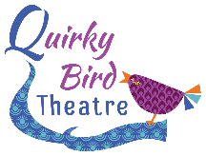

Technical Rider
Lighting
We require that the following be pre-rigged in anticipation of our get-in;
General Warm Wash
General Cool Wash
Left side isolation
Right Side isolation
Transitional Coloured State
Front Centre Spot
We use a strobe in the first 3 minutes of the show, please advise your students and alert us if this cannot be used prior to our arrival.
Sound Requirements:
Our sound runs from a tablet and needs to be plugged into your sound desk. Please inform us asap if you do not have a sound desk as we can provide our own.
If you have any questions please contact our Technical Manager David Jell at davidjell78@gmail.com
Other
Get in: 1hr
Get Out: 30 mins
Minimum performance space: 6m x 6m
Parking for three vehicles to be provided as close as possible to the loading area for our performance space. Where there is no lift and multiple stairs, please provide assistance from your site team.
Tea, Coffee and Water to be provided on arrival.
Anna Friend, David Jell and Jamie Carter are all DBS checked. Certificates available upon request. Anna Friend is the licenced chaperone for all actors under 16 years of age

