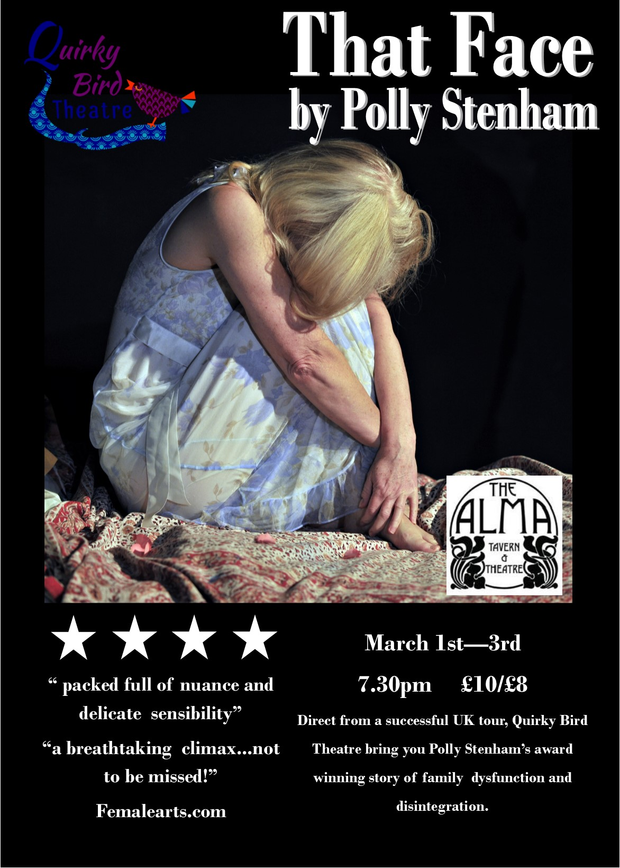

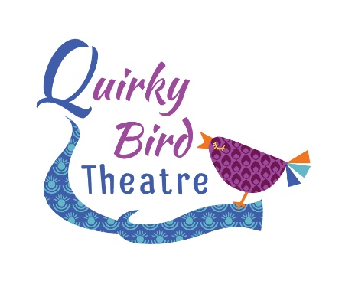

QUIRKY BIRD THEATRE
SCHOOLS TOUR THAT FACE BY POLLY STENHAM 2018
INFORMATION & PRICES

Thank you for interest in our schools tour of That Face by Polly Stenham. Quirky Bird Theatre has gained a strong reputation for its ability to produce strong affecting, naturalistic performances from their young actors. This production has been touring professional venues since February this year and has won several awards at local festivals including Best Play and Best Director. Since beginning our schools tour we have received an incredible response from students and teachers alike;
From the teachers:
“Just finished a fantastic workshop and performance evening with Quirky Bird Theatre and their touring production of Polly Stenham’s ‘That Face’. For anyone studying this for component 3, cant’ recommend them enough; really insightful, engaging and super intense!”
“todays lesson showed a great improvement already with performance choices and justifications from the students. Thank you Quirky Bird Theatre!”

From the students:
“such a rollercoaster of emotions! I feel exhausted and completely drained. Excellent insight into each of the characters and great to finally be seeing the performance”
“very clever take on the play. Brilliant to watch”
“ the performances were honest and completely genuine. Amazing work, you’ve opened my eyes”
“Really useful to watch and join in with. I genuinely enjoyed all the tasks and the opportunity to work with you all. Super talented!”
“I found the post show discussion really useful as it helped explore the characters in depth and to discover different interpretations of the characters”
“The performance was a different way of getting to know the characters and their complexity – it was very interesting”
“The post show session was very helpful in revising my ideas of the characters and the dynamics between them. I enjoyed the depth we went into. I liked the participation of the actors gave a sense of what it should be”
“Gob Smackingly Brilliant!”
If you have a large performance space that can accommodate 100+ audience members that you may be able to have us for free!!!
As a host school you will be able to invite other schools to the performance at your venue which could mean you end up paying nothing at all for your students to benefit from seeing this live performance. The cost for a host school is £1000 however if you are able to drum up enough interest and sell enough tickets, this will reduce your costs substantially.
We are hoping that this package will enable more students to access these productions and create a vibrant and exciting theatre experience for everyone who takes part.
The Host School Package allows schools to invite other local departments to buy tickets, through Quirky Bird Theatre, to their event which may result in your students gaining access to this performance for free. An example would be;
You have a theatre that seats 150 audience members. You have 45 students that would like to see the performance to enhance their exam preparation. You are able to sell the other 105 seats to interested schools, via Quirky Bird. Once the fee of £1000 has been reached, your school visit becomes free for you.
*If there is a deficit left over once the seats have been sold (for example, you are only able to sell a smaller proportion of tickets), you are liable to make up this cost, but this would also be substantially less that you would pay should we visit your school as a single visit.
Both the school and the company (Quirky Bird) will advertise this event to maximise uptake.
Tickets for the package will be £15 per student, which includes the live performance and post show Q&A of up to 45 minutes. All tickets are booked and paid for through Quirky Bird Theatre in line with the terms and conditions of our licence agreement with United Agents. In many venues you will only need to secure 70 tickets from other schools to ensure that your students go for free.
All cast members will be involved with the post-performance session and normally there is an opportunity to interact with the cast and director following the Q&A for more specific questions.
We require one of your own student actors to play the role of Alice. They must be able to concentrate well during the performance and be undistracted by their peers. This is a non-speaking role but they will have time prior to the performance to work with the actors as Mia and Izzy. They will have media make up applied for Scene 3 and therefore shouldn’t have a sensitivity to this. We will provide costume for this character.
We can be flexible on this schedule to a certain degree but the main things we must consider is the return to home time for our young performers and so travel time is a factor. On some occasions we would look for an earlier start time to accommodate this. Centres over 90 miles away will be asked to accommodate an earlier start time and fall under our long distance pricing.
All bookings are subject to a £100 confirmation fee which allows us to secure the performance rights from United Agents acting for Polly Stenham. This must be sent by post in order for us to confirm the booking.
Fees for the package are as followed; (long distance fees in brackets)
Performance and 90 minute post show session (max 40 students) £750 (£950)
* All bookings are subject to our cancellation policy.
If you need any more information regarding this project, please contact Anna Friend at quirkybirdtheatre@gmail.com or call on 07816 823555. For more information about Quirky Bird Theatre please visit our website www.quirkybirdtheatre.com.
In the meantime, if you’d like to book please complete the form below with a range of dates and we will get this confirmed for you. If you contact us by email please include the contact name, school name and full address with postcode at the time of enquiry.
Many Thanks
Anna Friend
Artistic Director, Quirky Bird Theatre
www.facebook.com/quirkybirdtheatre
@quirkybirdrocks

Booking form

School Name:
School Address:

School Contact Number:
Contact Name:
Contact direct email:
Contact direct number:
Number of students for Q&A/Workshop
Preferred Date 1
Preferred Date 2
Preferred Date 3
Ideal Start Time:
Cancellation Policy
In the instance that the venue cancels the following will apply;
28 days prior to the performance Full refund
14 days prior to the performance 50% refund
7 days prior to the performance No refund
In the instance that the company cancels a full refund will be issued.

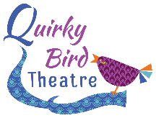

Technical Rider
Lighting
We require that the following be pre-rigged in anticipation of our get-in;
General Warm Wash
General Cool Wash
Transitional Coloured State
Front Centre Spot

Sound Requirements:
Our sound runs from a tablet and needs to be plugged into your sound desk. Please inform us asap if you do not have a sound desk as we can provide our own.
If you have any questions please contact our Technical Manager David Jell at davidjell78@gmail.com

Other
Get in: 1hr mins
Get Out: 30 mins
Minimum performance space: 4m x 4m
Maximum performance space: Any
Parking for one vehicle to be provided as close as possible to the loading area for our performance space. Where there is no lift and multiple stairs, please provide assistance from your site team.
Tea, Coffee and Water to be provided on arrival.
Anna Friend, David Jell and Oli Meredith are all DBS checked. Certificates available upon request.

