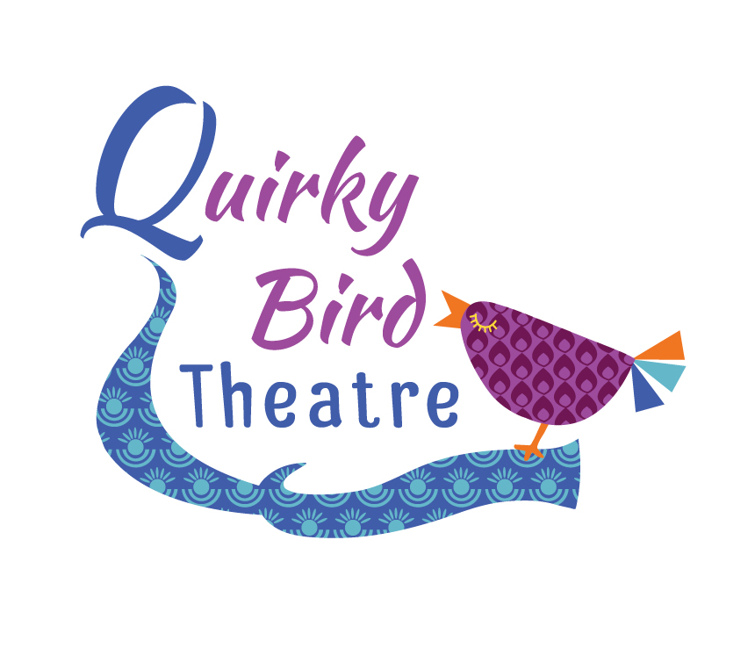
Quirky Bird Theatre
Child Protection Policy Statement

Quirky Bird Theatre acknowledges the duty of care to safeguard and promote the welfare of children and is committed to ensuring and safeguarding practice reflects statutory responsibilities, Government guidance and complies with best practice requirements.

This policy recognizes that the welfare and interests of children are paramount in all circumstances. It aims to ensure that regardless or age, gender, religion, beliefs, ethnicity, disability, sexual orientation or social economic background ALL children:

- Have a positive and enjoyable experience of actor training and performance at Quirky Bird Theatre in a safe and focused environment.
- Are protected from abuse whilst participating in these activities or outside these activities.

As part of our safeguarding policy Quirky Bird Theatre will:

- Promote and prioritize safety and wellbeing of children and young people.
- Ensure everyone understands their roles and responsibilities in respect of safeguarding our students and appreciates that they have a responsibility to voice and respond to any concerns.
- Ensure appropriate action is taken in the event of incidents/concerns of abuse and support provided to the person/s who raises or discloses their concerns.
- Ensure that any confidential, detailed and accurate records of all safeguarding concerns are maintained and stored securely.
- Prevent the employment/deployment of unsuitable individuals.
- Ensure robust safeguarding arrangements and procedures are in operation.

This policy will be reviewed every three years, or:

- Changes in legislation and/or Government guidance
- As required by the local safeguarding children board, or other interested parties

